Game Design Document

Fill up the following document

1. Write the title of your project.

Angry Birds Shooting Game

1. What is the goal of the game?

Shoot the pigs to save the birds

1. Write a brief story of your game.

This Story is about a beautiful bird village living in corner of a secrect world. Once the little baby birds ran out of their houses straight to the garden to enjoy with their friends, but little did they know a bunch of sneaky , cunning pigs who were spying on those little birds to kill them. You have entered the land and noticed this situation, its time you save the inocent little birds and save the day. So, hold your gun tight and kill those evil pigs. Do remember stay alert not to harm any birds or you may die!

1. Which are the playing characters of this game?

* Playing characters are the ones who respond to the user based on the input from the user.
* Cars, monkeys, dinos, wizards, etc., are the playing characters in the game.

|  |  |  |
| --- | --- | --- |
| Number | Character Name | What can this character do? |
| 1 | Birds | Playing |
| 2 | Pigs | Trying to kill birds |
| 3 | Player (gun) | Can kill the evil pigs ,might also shoot birds if not alert |
| 4 |  |  |
| 5 |  |  |
| 6 |  |  |
| 7 |  |  |
| 8 |  |  |

1. Which are the Non-Playing Characters of this game?

* Non-Playing characters are the ones that don't have an action or behavior when the user interacts with the game.
* Hurdles, stones, bananas, coins, etc., are non-playing characters in the game.

|  |  |  |
| --- | --- | --- |
| Number | Character Name | What can this character do? |
| 1 | Background | Enchances the game |
| 2 |  |  |
| 3 |  |  |
| 4 |  |  |
| 5 |  |  |
| 6 |  |  |
| 7 |  |  |
| 8 |  |  |

Draw your imagination of this game. What does this game look like?

* Draw the game either on your computer or on paper.
* Add images of the game scenes to show each of the playing and non-playing characters at least once.

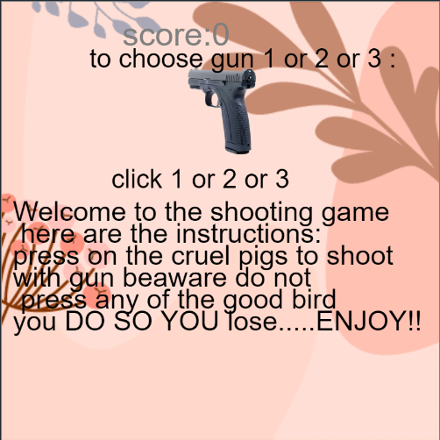

How do you plan to make your game engaging?

* + - 1. Make the game infinite to make the player play for long.
      2. Create more options so that the player can choose and design the game in their own way which helps to grab attention of the player.
      3. Create score board to make the player competetive and makes them play longer to win.